 | 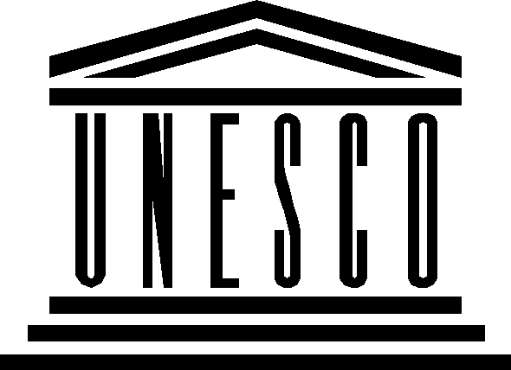 | 

Action Line C3 “Access to information and knowledge”

Working methods of the multi-stakeholder team

Preliminary proposal

- Introduction

Action Line C3 recognizes the importance of access to information and knowledge as a key factor for the development of individuals, organizations and communities, as well as the crucial role of ICTs by allowing people, anywhere in the world, to access information and knowledge almost instantaneously. Accordingly the Action line C3 defines ten areas of action from (a) to (j) that are essential to access to information and knowledge.

Given the breadth of the topics covered under Action Line C3 and considering the varied expertise and priorities among stakeholders, the following thematic clustering of Action Line C3 in seven specific topics is proposed:

- Enabling environment for access to public information
- Community access
- Libraries and archives
- Software models
- Research and Development
- Open Access
- E-Government

Each of them could be further divided according to topics or target groups.

B. Possible thematic clusters and corresponding working groups

- Enabling environment for access to public information
Objectives:
- Developing policy guidelines for the development and promotion of public domain information as an important international instrument for promoting public access to information (Action a)
- Providing adequate access through various communication resources, notably the Internet, to public official information (Action b)
- Encouraging the establishment of legislation on access to information and the preservation of public data, notably in the area of the new technologies (Action b)
Stakeholders: to be identified during the meeting

- Community access
Objective(s):
- Establishing sustainable multi-purpose community public access centres, providing affordable or free-of-charge access for citizens to the various communication resources, notably the Internet (Action d)
Stakeholders: to be identified during the meeting

- Libraries and archives
Objectives:
- Supporting the creation and development of a digital public library and archive services, adapted to the Information Society (Action h)
- Reviewing national library strategies and legislation (Action h)
- Developing a global understanding of the need for "hybrid libraries" (Action h)
- Fostering worldwide cooperation between libraries (Action h)
Stakeholders: to be identified during the meeting

- Software models
Objectives:
- Promoting awareness among all stakeholders of the possibilities offered by different software models, and the means of their creation, including proprietary, open-source and free software, in order to increase competition, freedom of choice and affordability (Action e);
- Encouraging research and development of the design of useful instruments for all stakeholders to foster increased assessment, and evaluation of different software models and licences, so as to ensure an optimal choice of appropriate software that will best contribute to achieving development goals within local conditions (Action j).
Stakeholders: to be identified during the meeting

- Research and Development
Objectives:
- Promoting research on the Information Society, including on innovative forms of networking, adaptation of ICT infrastructure, tools and applications, to facilitate accessibility of ICTs for all, in particular disadvantaged groups (Action g).
- Promoting research and development to facilitate accessibility of ICTs for all, including disadvantaged, marginalized and vulnerable groups (Action c)
Stakeholders: to be identified during the meeting

- Open Access
Objective(s):
- Encouraging initiatives to facilitate free and affordable access to scientific information, including open access journals and books, and open archives (Action i)
Stakeholders: to be identified during the meeting

- E-Government
Objective(s):
- Promoting the use of ICTs as a fundamental working tool for citizens and local authorities and to support capacity building for local authorities in the widespread use of ICTs as a means of improving local governance (Action f).
Stakeholders: to be identified during the meeting

C. Possible activities of C3 multi-stakeholder team

The tasks of each Working Group would be to:

- Identify concrete activities and/or group of activities for common implentation;
- Implement concrete activities which respond to the respective objectives of the Working Group;
- Exchange knowledge, experiences and best practices in the respective topic, using online tools, and promote them at national and regional level;
- Strengthen international cooperation in the respective topic and pilot initiatives jointly designed, co-funded and implemented;
- Monitor and report new findings, developments and initiatives in the respective topics.

- Modalities of reporting
Multi-stakeholder team
Group
A
Facilitator
Report
Report
Report
Report
Focal point
Focal point
Focal point
Focal point
Report
Physical meeting
Group
B
Group
C
Group
D
- Implement concrete activities
- Exchange knowledge, experiences and best practices
- …

On line meetings
Annex

Text of the Action Line C3 “Access to information and knowledge”
in the Geneva Plan of Action

10. ICTs allow people, anywhere in the world, to access information and knowledge almost instantaneously. Individuals, organizations and communities should benefit from access to knowledge and information.
- Develop policy guidelines for the development and promotion of public domain information as an important international instrument promoting public access to information.
- Governments are encouraged to provide adequate access through various communication resources, notably the Internet, to public official information. Establishing legislation on access to information and the preservation of public data, notably in the area of the new technologies, is encouraged.
- Promote research and development to facilitate accessibility of ICTs for all, including disadvantaged, marginalized and vulnerable groups.
- Governments, and other stakeholders, should establish sustainable multi-purpose community public access points, providing affordable or free-of-charge access for their citizens to the various communication resources, notably the Internet. These access points should, to the extent possible, have sufficient capacity to provide assistance to users, in libraries, educational institutions, public administrations, post offices or other public places, with special emphasis on rural and underserved areas, while respecting intellectual property rights (IPRs) and encouraging the use of information and sharing of knowledge.
- Encourage research and promote awareness among all stakeholders of the possibilities offered by different software models, and the means of their creation, including proprietary, open-source and free software, in order to increase competition, freedom of choice and affordability, and to enable all stakeholders to evaluate which solution best meets their requirements.
- Governments should actively promote the use of ICTs as a fundamental working tool by their citizens and local authorities. In this respect, the international community and other stakeholders should support capacity building for local authorities in the widespread use of ICTs as a means of improving local governance.
- Encourage research on the Information Society, including on innovative forms of networking, adaptation of ICT infrastructure, tools and applications that facilitate accessibility of ICTs for all, and disadvantaged groups in particular.
- Support the creation and development of a digital public library and archive services, adapted to the Information Society, including reviewing national library strategies and legislation, developing a global understanding of the need for "hybrid libraries", and fostering worldwide cooperation between libraries.
- Encourage initiatives to facilitate access, including free and affordable access to open access journals and books, and open archives for scientific information.
- Support research and development of the design of useful instruments for all stakeholders to foster increased awareness, assessment, and evaluation of different software models and licences, so as to ensure an optimal choice of appropriate software that will best contribute to achieving development goals within local conditions.

Draft prepared by UNESCO Secretariat (16 October 2006, UNESCO Headquarters, Paris).
This topic is also addressed under Action Line C7 "E-science" and actions should be taken conjointly with the multistakeholder team working on that Action Line.
This topic is about capacity-building of local authorities and is also addressed under Action Line C7 "E-government". Actions should be taken conjointly with the multistakeholder team working on that Action Line.

